Dr. MUHAMAD MUSTAFFA K.
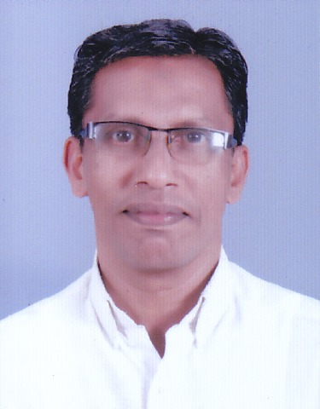
Asst. Professor, Special Education (Research Methodology)
No. 2 MGU Teachers Apartment, PD Hills, Athriampuzha, Kottayam 686560
Cell. 9946226638
E mail: mustafamgu@gmail.com
Qualification
MSc. M.A., M.Ed., M.Phil., Ph.D., B(SP)Ed., PGDEC. PGDSE. PGDC
Teaching Experience
9 Years - Special Educator, 9 years - Asst. Professor
Other Positions
_ Rehabilitation Professional–(Rehabilitation Council of India–RCI)
_ Resource Person (SCERT, Govt. of Kerala)
_ Member, Special School Curriculum Committee, Department of Education,
Govt of Kerala
_ Hon. Director Institute of Research in Learning Disability (IRLD), M.G. University
Joint Director, Inter University Centre for Disability Studies (IUCDS), MG University
_ Member – M.G. University Campus Development Committee.
_ Faculty in charge of Department of Indian Sign Language, M.G. University
_ Faculty in charge of Equal Opportunity cell, M.G. University
_ Member Research Committee Kerala Higher Education Council
_ Special Officer Department of Rehabilitation Sciences, Calicut University
Membership in Academic Bodies
_ Chairman Board of Studies (BOS) Lifelong learning and Extension, University
of Calicut
_ Member BOS Psychology, Kannur University
_ Member BOS Education Kannur University
_ Member BOS Behavioural Sciences, M.G. University
_ Member BOS Education M.G. University
_ Coordinator Certificate course in LD, DLLE, M.G. University
Areas of Research Interests
Teacher Education in Disability Studies, Research Methodology in Behavioural sciences, Learning Disabilities, Special Education , Integrated and Inclusive Education
Areas of Teaching Interests
Research Methodology, Learning Disabilities, Special Education, Disability Studies,
Behavioural Sciences
Ongoing Research
_ Exclusive tendency in Inclusive Education (SSA Sponsored)
_ Study on Personality and Teaching competency among Teacher Trainees of
Special Education
_ Development of Screening test for identification of Learning Disabilities
_ Study on efficacy of Remedial Teaching Module for the management of
Learning Disabilities
Project
_ Exclusive tendency in Inclusive Education (SSA Sponsored)
_ Impact of DPEP on Integrated education for disabled children (IEDC) - Dept.
of General Education , Govt. of Kerala (Completed)
_ Post training activities of Rehabilitation professionals with reference
to persons with hearing impairment -National Institute of Hearing
Handicapped - (AYJNIHH) Mumbai – Co-investigator
Membership in Professional Bodies and NGO’s
_ Special Educators Council for Research and Development - (President)
_ Kerala Sign Language Academy (Chairman)
_ Association for Welfare of the Handicapped - AWH (Member)

