Foot Print 2016
(Alumni Association OF SMBS)

The alumni association of School of Management & Business Studies has a history of 17 years of dedicated work, through which it has earned a priceless legacy, created mainly by the generations of illustrious teachers and students, who have adorned covetous positions in different fields of activity. The school has always been fortunate to see its alumni gratefully acknowledging their alma mater’s role in moulding their future. It is the deep sense of belonging , gratitude and commitment on the part of these former students and teachers that resulted in the formation of the SMBS Alumni Association known under the brand name “Foot Prints”.
The Association intends to gather the support of the alumni to develop and sustain strong ties with each other and with the department. The alumni association promotes interaction among alumni in an area and provides newcomers with valuable social and professional contacts. Membership also provides a way for alumni to help each other as well as prospective students, current students, and young alumni who seek guidance in pursuing their education and in starting their careers. This would certainly provide all members the satisfaction of having developed and implemented programs that promote the interests of the school and its alumni.
The alumni association has a very significant role in projecting and carrying out the mission of the University and the school. The other roles are, the enhancement the reputation of the Department and the University, funding activities, placement assistance, organizing alumni meets, seminars, supporting the students in finding place for their organization study, project study and other events. The annual meeting of Foot prints has been conducting continuously for the last 6 years right from 2010, the year of formation. Every year the smbs alumni has been continuously contributing the price money of all the events ( about Rs 35,000) of programme “Beacon” the management fest conducted by the students of SMBS. The summary of the minutes of the alumni conducted in 2016 and some selected photographs is shown below.
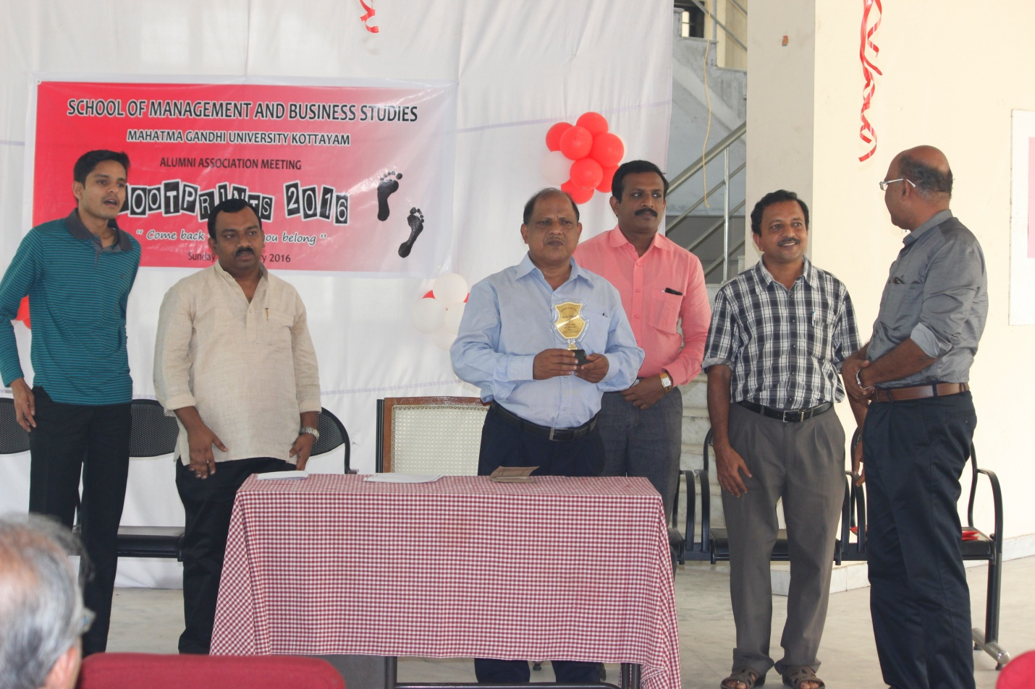

Report of the Alumni Meeting – Footprints 2016.

Programme started at 11.a.m on 14th Sunday February 2016, Presided by the Director, SMBS
35 Alumni members were present. From SMBS 80 MBA students were also present.
The meeting discussed many matters to strengthen the alumni. The following are the business transactions held during the sessions.
- Alumni of 1999-2001 batch as agreed to give support in bringing up a garden in the central quadrangle of SMBS building. The planting of a tree as symbolic inauguration was done by the batch.
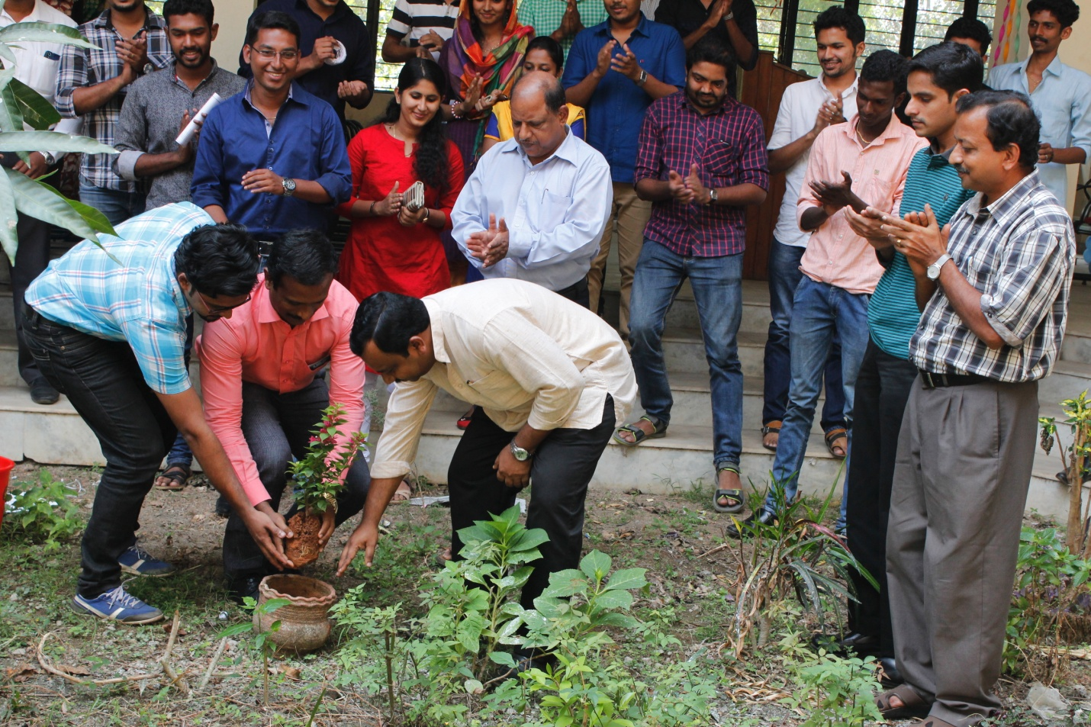
- The best outgoing student award constituted by 2012-2014 batch by giving a cash award and a Trophy.
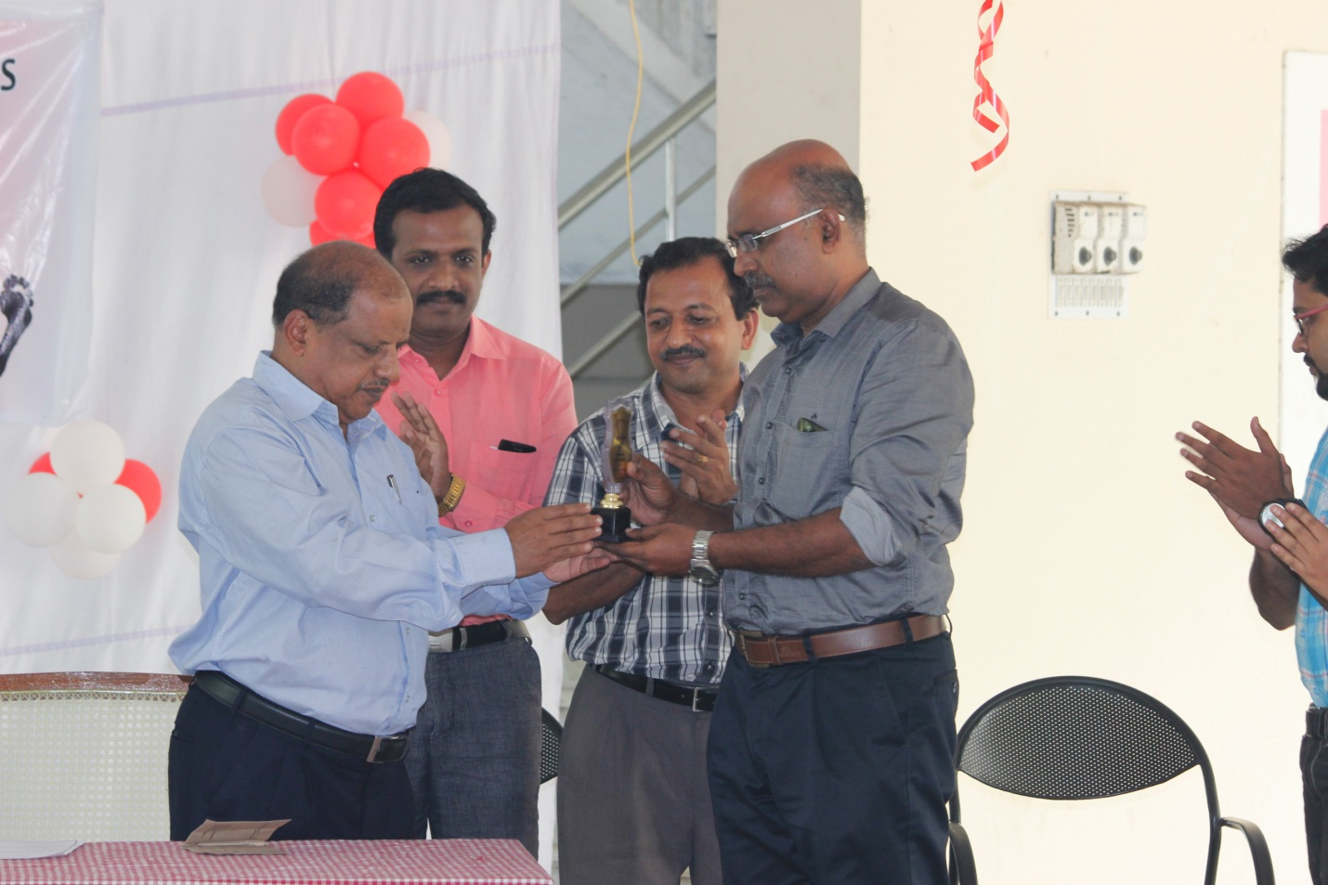

- Cultural Programmes were held in the after noon where the alumni’s and current year MBA students being participated.
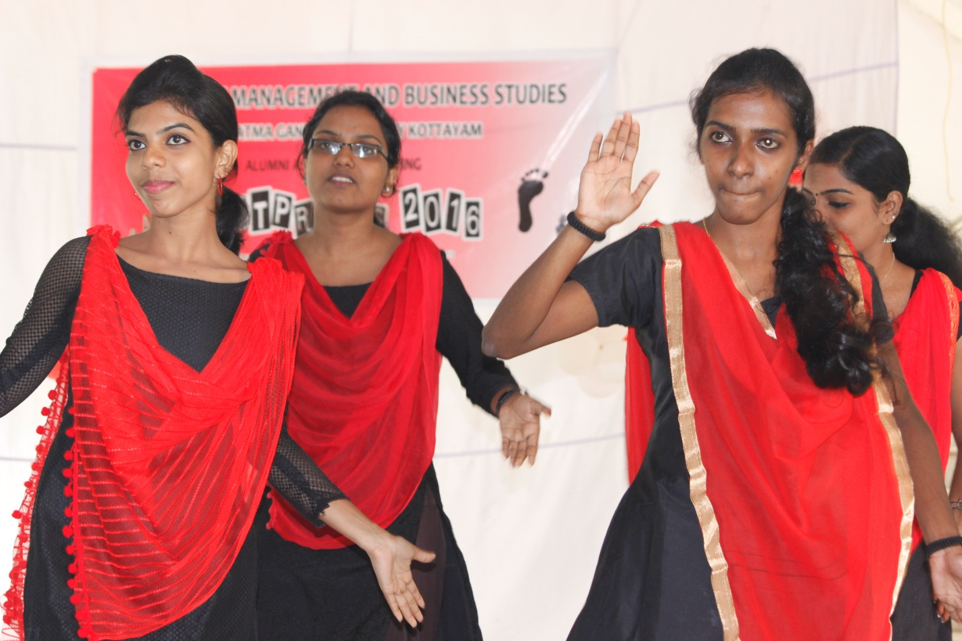

- The Batch 2013-15 has agreed to take initiative in hosting a management education web portal and also the developing a lawn in sliding court yard in front of SMBS
- The alumni meetings will be conducted on the second Sunday of January, every year for advance planning and trip arrangement.
- More effort has to be taken to contact the senior alumni’s to explore their help as resource person/placement/Project/Organization study related activities.

Responses of the alumni were collected on the course structure by asking suggestions based on the current industrial or job requirement. The meetings comes to end at 4 p.m.

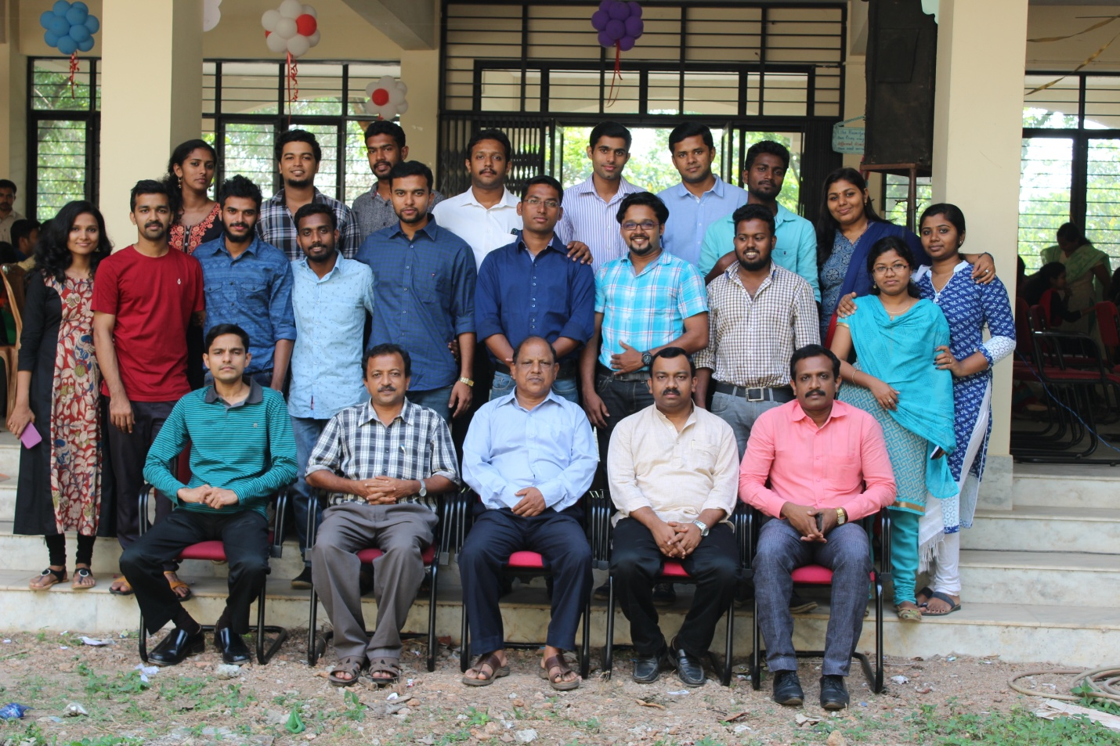

SCHOOL OF MANAGEMENT AND BUSINESS STUDIES
MG UNIVERSITY, KOTTAYAM
Footprints2016

Date: 14-02-2016, SUNDAY
Venue: SMBS, MG UNIVERSITY
PROGRAMME
10.00: reception and drinks
10.30: Prayer song
10.35: Welcome Speech (Dr. Sajimon Abraham, Faculty Member)
10.45: Message (Dr. K Sreeranganadhan, Director- SMBS)
11.00: Felicitation speech by Faculties (Dr. E.Suliaiman, Dr.Santhosh P.Thampi, Dr.Johnney
Johnson, Dr.Biju M.K, Dr.Afsal)
11.30: Song by Vishnu V.P
11.35: Experience sharing by alumnus
11.55: Song by Shawn Jacob Mathew
12.00: Experience sharing by alumnus
12.15: Installation and distribution of proficiency prizes for the best outgoing students sponsored
by 2012- 2014 batch)
: Initiation of quadrangle garden project sponsored by 1999-2001 Batch
12:45: martial arts performance by Irshad. P
1.00: lunch Break
2.05: Experience sharing by seniors
2:40: Cultural programme by students & alumnus
4.00: Vote of Thanks, National Anthem

* the order and timings of programme may subject to change

